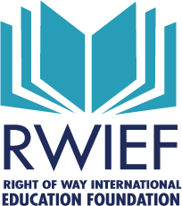

2024 Donation Form

DONATION AMOUNT - $_______________

Check No. __________

Mail Checks to: Matt L McGee, SR/WA, NuStar Energy,19003 IH – 10 West
San Antonio, TX 78257 Make checks payable to “RWIEF”
Please notify Matt via email at matt.mcgee@nustarenergy.com when your donation check is placed in the mail. Thank You for your continuing support of RWIEF!

___ We’ll mail you a check

Your Name ______________________________________

On behalf of:

Chapter No. ____________ Region No. ______________

Company Name _______________________________________________

Mailing Address ________________________________________________

________________________________________________________________

Phone Number _________________________________________________

Email Address __________________________________________________

On behalf of the International Right of Way Education Foundation, THANK YOU for your support! The future of the right of way profession lies in the ability to develop and obtain quality education. Our society dictates a constant need for an increased level of education. The mission of the Right of Way International Education Foundation is to continue to work diligently and creatively to obtain and maintain the funds needed to support the initiatives that expand the level of education for right of way professionals.
Leslie Finnigan, SR/WA President, RWIEF

